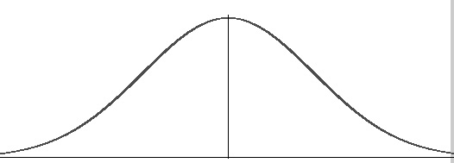

Nonlinear transformation

f

= Sigma Points

Sigma Point Matrix

dn x d2n + 1



Transformed SPM

dx x d2x + 1

+

Calculate Weights

1

n

n

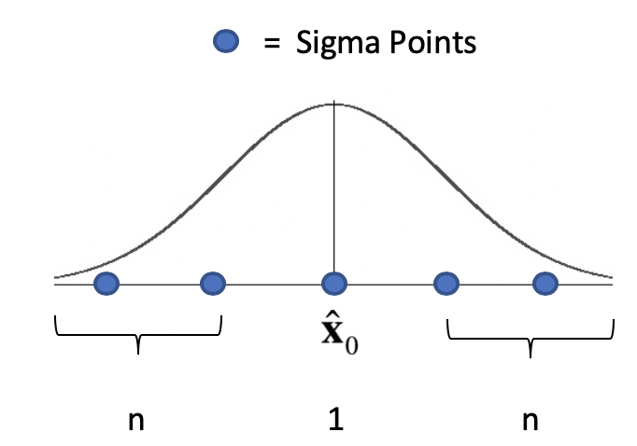

. . . . . . . . . . . . . . .

2n + 1

n

Sigma Point Matrix

Calculated Weights +



=